Animating Text in Adobe Flash
Tutorial by Matt Kemp
In this tutorial, you will learn to animate the individual letters of a word and have them come together to form the word. You may use any word that you would like. Try to keep the word to only 4 or 5 letters as the more letters you will have, the more complicated the project will get. For the sake of this tutorial, I will use the word 'Flash'.
Step 1: Open a new Flash file.
Step 2: Before we get started, we need to create a separate layer for each letter. Click on the New Layer Button to create a new layer for each letter.
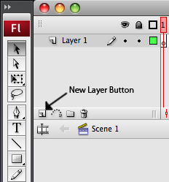

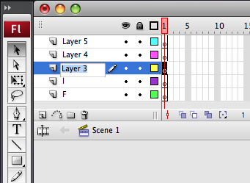
Step 3: Once you have created the layers you need, rename each of them to a separate letter of the word. To rename a layer, double click it to bring up the text box. Rename each layer like this.

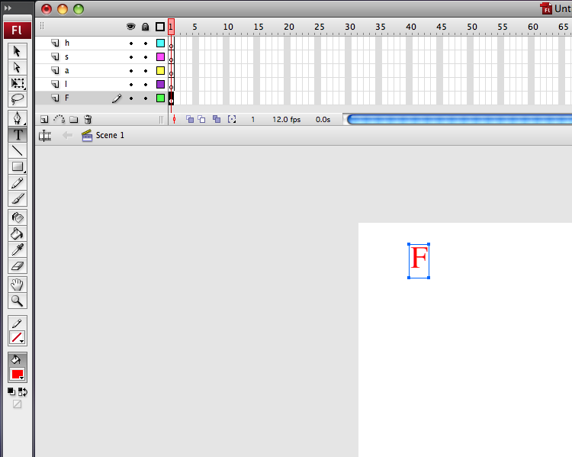
Step 4: Now we will start creating the letters. Select a layer and click the Text tool. The Text tool is the capital T in the tool bar. With the Text tool selected you will see text options at the bottom of the screen such as font size, color and font type. Change the font type and color to whatever you wish. As for font size, set it to 40. Once you have your settings set, draw a text box and type in the letter of whatever layer you are on.

Step 5: Now use the text tool to place the other letters in random locations on the canvas.
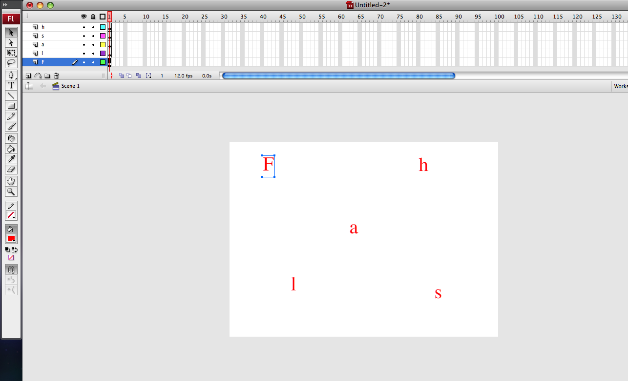
Step 6: Next, go to the frame timeline at the top of the screen and click on frame 5. Flash counts frames in segments of 5. Every 5 frames will be gray. Click frame 5, then right click and select Insert Keyframe. Save your work now.
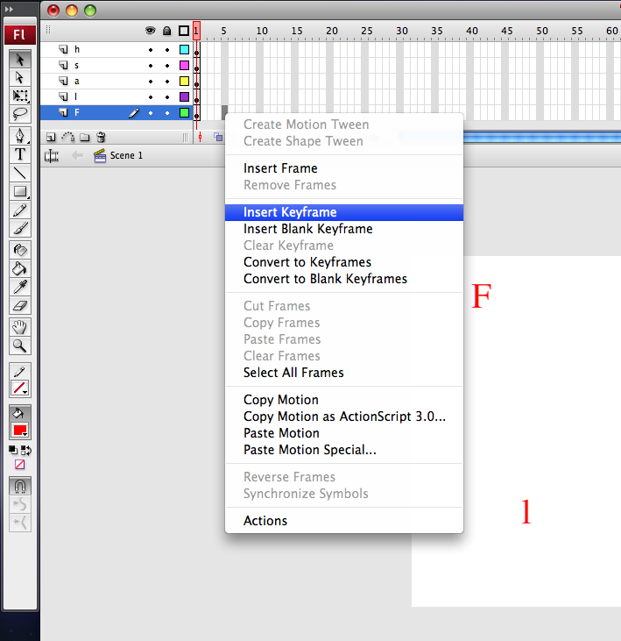

Step 7: Insert a Keyframe at frame 5 for each of the layers. Now we are going to repeat this process on frames 10, 15, 20, 25, and 30. Your frame timeline should look like this.
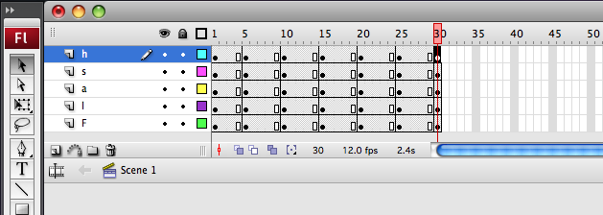

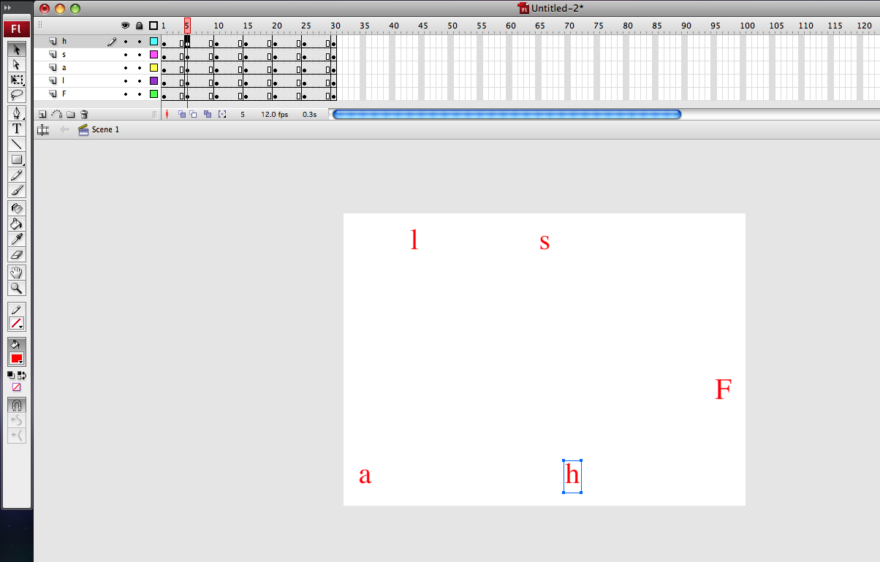
Step 8: Now we will start to scatter the letters. For each letter, click on the keyframe at frame 5 on it's layer and move it to another location on the canvas.

Step 9: Repeat what you did in Step 8 for the keyframes on frames 10, 15, and 20. Take your time on this step to make sure that each letter has been moved and that they are in a different location than the keyframe before it. Save your work often here.

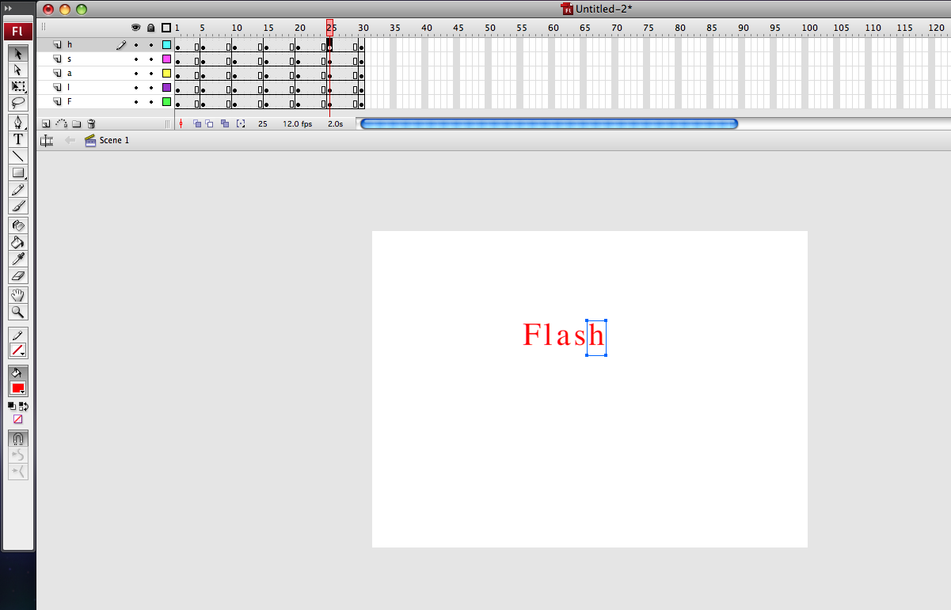
Step 10: For the keyframes on frame 25 we are going to have the letters come together to form whatever word you chose to do. Select the first letter of the word and place it somewhere on the canvas. Then move each letter into place behind it.

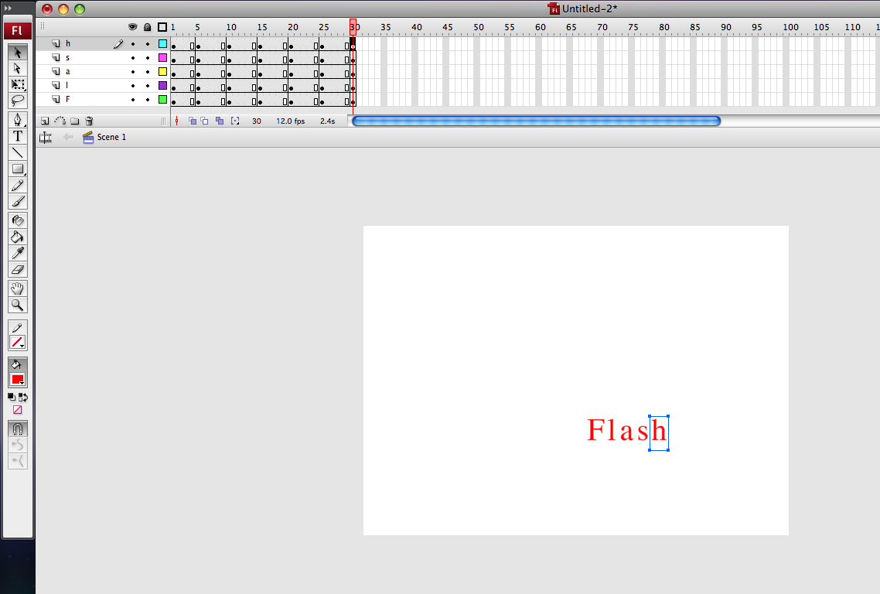
Step 11: Now we are going to do the same thing that we did in at frame 25 at frame 30. Move the first letter of the word to another location on the canvas and bring the letters in behind it.

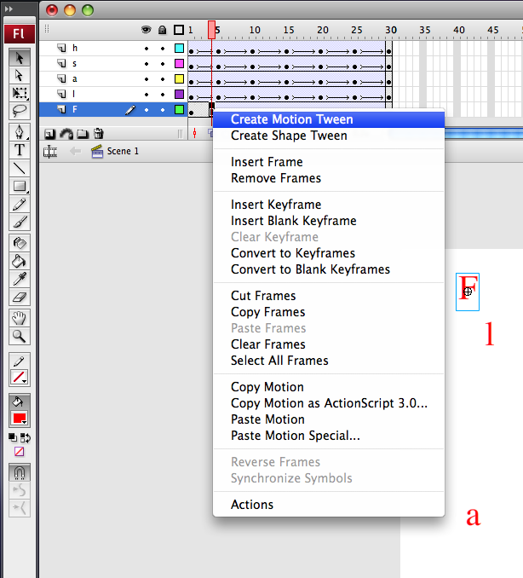
Step 12: For the final step, we are going to add motion to each of the letters. Click on the frame before each keyframe, which should be frames 4, 9, 14, 19, 24, and 29. These frames should have a white box in them. Once the frame has been selected, right click and select Create Motion Tween. This adds motion to each of the letters. Once you add a motion tween to each segment, you are done! Save your work and prepare to turn it in.

